**Problem Set 2**

1. What value is displayed when the last expression (a) is evaluated? Explain your answer by indicating what happens in every executed statement.

While calling function b, global a variable set and then call function c which increment value of a by 2 using addition function. I had called function b so a value increment by 2 three times, so it became 6. If we call function b 4 times, then value of a became as 8.

1. Function fileLength()

1. Write a function called Marsupial

1. Write a function collatz()

1. Binary Function

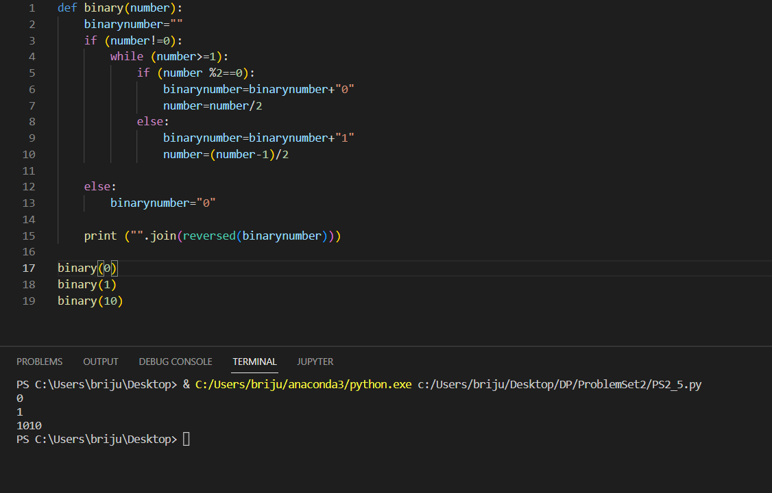

1. HeadingParser

1. Webdir
2. SQL Queries
3. All the Temperature data

1. All the cities, but without repetition

1. All the records for India

1. All the fall records.

1. The city, country, and season for which the average rainfall is between 200 and 400 millimeters.

1. The city and country for which the average Fall temperature is above 20 degrees, in increasing temperature order.

1. The total annual rainfall for Cairo

1. The total rainfall for each season.

1. Write list comprehension expressions

